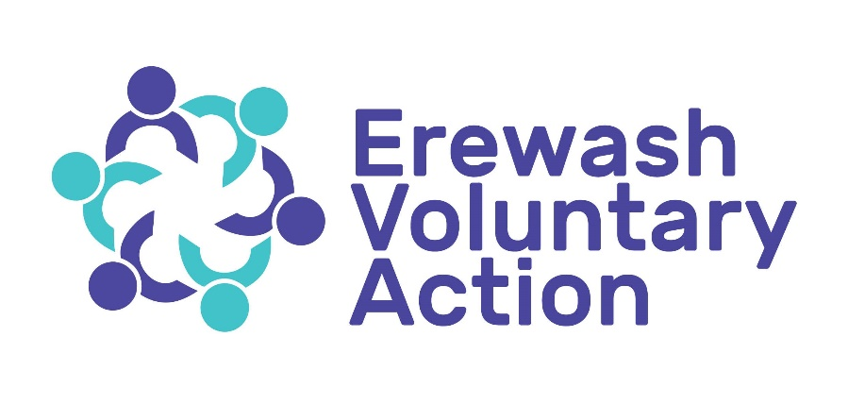

Living Well Locality Co-ordinator

Candidate Information Pack
External Application

March 2024

Thank you for your interest in the post of Living Well Locality Co-ordinator.
We hope this recruitment pack will provide you with the information required to enable you to decide whether you wish to apply for the post.
EVA leads and supports the voluntary and community sector in Erewash. We provide numerous services, including supporting the voluntary sector and building capacity and impact, through funded programmes. We also have several funded projects including shopping, volunteering, Social Prescribing and Derbyshire Mental Health Forum. We have a large centre that the charity owns, and we hire rooms out to organisations within the community. We have 23 members of paid staff and 165 registered volunteers.
The post holder will lead the work to chair the living well collaboratives across the Southern Derbyshire area.
37 hours, including some weekend and evening working
Salary: £28,000 per annum - 12-month fixed term contract
Are you enthusiastic about empowering people to promote good mental health?
If you can form strong links with the Living Well Programme Team and local leadership, responsible for leading the development of the collaborative work to support transformational change, in line with the ‘NHS Long Term Plan’ for mental health, Community Mental Health Framework and Derbyshire Living Well, then we would love to hear from you.
The Collaboratives are an inclusive forum where people come together to develop a shared understanding of the current mental health system. These face to face and virtual meetings will enable an opportunity to listen to local voices, share the offer and respond to local mental health needs. The successful candidate will be working with partners to ensure that organisations regardless of their size are able to attend the collaborative meetings and shape services locally.
There will be three posts, one hosted by Erewash Voluntary Action and the others by our partners in Chesterfield. North East Derbyshire, Bolsover and the High Peak.
Please download an application pack from https://www.erewashvoluntaryaction.org.uk/jobvacancies
CLOSING DATE FOR APPLICATIONS: 13th May 2024 12 noon
INTERVIEW DATE: 20th May 2024
If you would like to play a role in the future of EVA and the services we deliver and you meet the requirements of our person specification please complete the application form.
Best Wishes
Stella Scott
Chief Executive Officer
stella@erewashcvs.org.uk

How To apply:
- If you are interested in applying for this role, please complete the attached application form and return marked Private and Confidential to Stella Scott CEO.
- When completing the application form, please refer to the requirements of the person specification. Give examples to back up your statements.
- If you have any other queries in relation to the role, please email stella@erewashcvs.org.uk
- The interview panel will consist of the Chair of the Trustees, the Operations Director, Mental Health Policy Officer and the CEO.
Timetable and process:
Closing date for applications
on.
We will invite a shortlist of candidates to participate in an interview and assessment process on the
If successful, you will be asked to prepare a 10 minute presentation (the topic will be given 5 days prior to the interview).

This post requires a Disclosure and Barring Service check.

Living Well Locality Co-ordinator
Job Description
Post: Living Well Locality Co-ordinator.

Host Organisation: Erewash Voluntary Action

Responsible to: Mental Health Policy and Engagement Officer

Location: Base: Erewash Voluntary Action, covering Erewash, Amber Valley and South Derbyshire

Contract length: 12 months

Hours: 37 hours per week

Salary: £28,000 per annum
The successful post holder(s) will form strong links with the Living Well Programme Team and local leadership, responsible for leading the development of the collaborative work to support transformational change, in line with the ‘NHS Long Term Plan’ for mental health, Community Mental Health Framework and Derbyshire Living Well.

The main duties of the post will entail working within an agreed Work Plan to:
- Assume complete responsibility for coordinating and managing collaborative meetings, ensuring smooth administration and organisation.

- Lead the facilitation of meetings, including agenda preparation, coordinating presenters, attendees, and liaising with host organisations and stakeholders.

- Ensure well-organised and well-attended collaborative meetings, ensuring timely distribution of agendas and pertinent documents to all participants.

- Develop actionable plans for each meeting, delineating clear tasks and assigning responsible individuals for implementation.

- Establish Terms of Reference for Collaboratives as necessary to ensure clarity and alignment.

- Work alongside and form partnerships with the local community, voluntary sector, and those with lived experience to build an understanding of the complexities of change for those in a service provision role, ensuring that grassroot groups are involved in discussions.

- Cultivate connections with communities of interest and individuals with protected characteristics through established affiliations with specialised support and advocacy organisations.

- Organise discussion groups, events, and participation in external events to facilitate dialogue with community members who have lived experience with mental health issues.

- Engage frontline workers to promote their participation in collaboratives and to relay valuable insights to the teams.

- Serve as the primary contact for the designated locality, communicating change processes, collaborating with the Derbyshire Collaborative to address key concerns, and leveraging insights to facilitate solution development.

- Facilitate discussions on co-design and co-production, leveraging organisational voices to bolster local initiatives through collaboration, with a focus on supporting mental health forums such as the Derbyshire Mental Health Forum and Derbyshire Voluntary Action’s Mental Health Liaison Service.

- Encourage and identify opportunities among local provider networks to innovate and pilot ideas under the Living Well initiative, contributing to existing mental health forums, networks, and local infrastructure.

- Strengthen existing connections with broader networks and forums within the area.

- Collaborate with individuals with lived experiences to create compelling marketing materials.

- Work alongside key agencies and local infrastructure to create synergy and collaboration.

- Carry out agreed monitoring and evaluation procedures, delivering reports on work progress and its impact on individuals and staff.

- Fulfil any additional duties as required, aligning with the wider overarching objectives of the organisation.

- Adhere strictly to the employer's Terms and Conditions of Employment and supporting policies, ensuring confidentiality in all work-related matters.

PERSON SPECIFICATION
JOB TITLE: Living Well Locality Co-ordinator
Skills & Knowledge | Essential | Desirable
Excellent communication both written and verbal
Strong organisational skills and an ability to grow relationships and listen to the local voice of people and communities using data and lived experience stories.
The ability to identify and address inequalities that will support the facilitation and co-design work.
Accurate record keeper
Ability to network and establish positive relationships with partner organisations to influence change
Good computer literacy
Knowledge of recent mental health policy issues
Understanding of equality and diversity
Knowledge of the voluntary sector
Experience of Mental Health projects
Knowledge of Mental Health issues
Knowledge of the Derby and Derbyshire area
Experience | Essential | Desirable
Experience of using social media
Experience of working in or with the voluntary sector
Experience of minute taking for a wide range of meetings
Experience of providing accurate and timely management information for internal and external reporting
Experience of chairing meetings
Experience with people having mental health issues
Demonstrated experience of co-ordinating projects in complex and challenging environments
Experience of organising promotional/ engagement activities
Basic mental health and suicide prevention awareness
Qualifications | Essential | Desirable
Educated to a good standard
Demonstration of personal development and on-going learning
Aptitude, Values and Behaviour | Essential | Desirable
Self-motivated and a positive approach to problem solving
The ability to cope under pressure in meetings
Evidence of effective team working
Ability to work outside office hours when required (with reasonable notice)
Ability to prepare and produce concise yet insightful communications for dissemination to a wide range of partners/stakeholders
Experience of creating and giving presentations to a varied group of internal and external stakeholders
Willingness to work flexibly to meet the needs of the organisation
Ability to travel independently across the specified area and occasionally beyond
A strong belief in the value of working with all partners in a collaborative way
Respectful and build trust
Compassionate to self and others
Excellent team worker
Value and support other people
Engage and encourage
Value learning and innovation
Good sense of humour
Qualifications in mental health (mental health first aid/suicide prevention training/mental health awareness
Aptitude, Values and Behaviour | Essential | Desirable
Self-motivated and a positive approach to problem solving
Ability to cope under pressure
Evidence of effective team working
Ability to work outside office hours when required (with reasonable notice)
Experience of creating and giving presentations to a varied group of internal and external stakeholders
A strong belief in the value of working with all partners in a collaborative way
Respectful and build trust
Compassionate to self and others

Guidance notes on completing the Application Form.
You are advised to read the following notes carefully as the decision to shortlist you for interview will be solely based on the information you provide on the form. This advice is designed to help you complete the application form as effectively as possible.
General guidance notes
Please read all notes before completing your application.
All Erewash Voluntary Action job packs contain a job description, person specification and information about our organisation. Read all of this carefully before completing your application.
Decisions about who will be selected for interview will be based only on the information you give in your application form. Therefore, the application form should be filled in as completely and clearly as possible. Pre-prepared Curriculum Vitae (CV) will NOT be accepted with this application.
Copies of references and qualification certificates should not be enclosed with this application.
False or misleading information on this form will disqualify your from appointment, or if appointed will render you liable to dismissal without notice.
Preparing your application
Look carefully at the job description and person specification. The person specification sets out the minimum skills, knowledge and experience required by Erewash Voluntary Action to do the job. Your application will be assessed to see if you meet the requirements of the person specification. This document will be used throughout the selection procedure.
Make sure the information in your application relates directly to the job you are applying for. Don’t just copy and paste from other job applications or from your CV.
Completing your application
Read the form fully before you complete it.
Please type or word-process your application if possible. If you are not able to do so please complete the form clearly using black ink.
Personal details: Complete this information on the form provided and remember to submit it with your application form. This will not be seen by the shortlisting panel.
References: If you have been employed, one reference must be your present or previous employer. If not, think of someone who can say something useful or relevant about you. Referees cannot be related to you or live with you. Please ensure that you have obtained the permission of your referees.
Employment history: Provide details of present and past employers and posts. Remember volunteering this can be as relevant as paid work experience. You must use the space on the form for your work history. Do not send it separately.
Education: The holding of an education qualification will only influence shortlisting where this is specifically stated in the person specification as an essential requirement. Include any training that has not led to any qualification/accreditation as this is good evidence of continuing personal and professional development.
Skills, Knowledge and Experience: this is where you make your case for your ability to do the job. Pay careful attention to the Person Specification as this is what the shortlisting panel will use to access your application. You are unlikely to be shortlisted unless you meet most, or all of the essential criteria listed in the person specification. The shortlisting panel will be looking for evidence that illustrates relevant skills, knowledge and experience.
Take each point in the person specification in turn and describe how you meet each one. What evidence can you provide to demonstrate that you have the necessary skills, knowledge and experience? You need to DEMONSTRATE that you have the skills, knowledge and experience necessary to do the job. It will not be sufficient simply to say that you fulfil certain criteria and unsupported statements will not be accepted. You should describe how you meet the person specification giving examples.
Think about your experience. How can you show that you have the skills, knowledge and experience necessary to do the job? Explaining your past and present jobs or interests to someone else may help you uncover hidden skills that you take for granted.
Remember unpaid work and work at home can be just as relevant as paid work. Consider experience that you have acquired outside work, such as community, voluntary or leisure interests.
Do a rough draft first and proofread it to check for mistakes (e.g. spelling) and accuracy. Have you answered every question? Have you signed and dated the declaration at the end of the form? Always keep a copy of the form for your own reference.
Make sure the form is returned to the correct postal address (with the correct amount of postage paid) or email address by the closing date/time.
Late applications will not be considered.
If you have any general enquiries about your application, please contact the person whose name appears at the front of the application pack.

Appendix 1: Organisational Chart for new structure
CEO in Dark Orange and top tier posts in Yellow - Senior Management Team (CEO line manages Operations director)

