Erewash Voluntary Action CVS Ltd (EVA)

APPLICATION FOR MEMBERSHIP

Name of group/organisation:

Main Contact:

Official postal address:

Telephone number:

Email:

Web address:

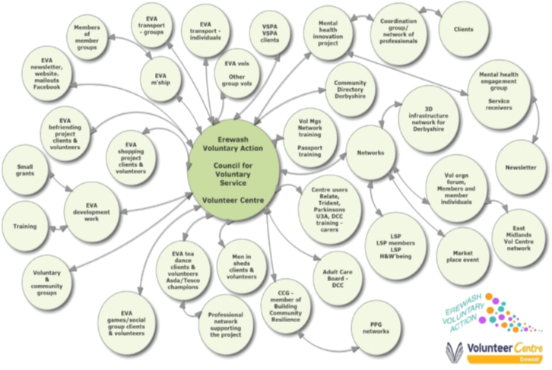



PTO
Is your group a registered charity? YES/NO

Registered charity number:

Brief description of the aims and activities of your organisation:

Does your group have a governing document (set of rules, constitution or memorandum and articles of association)? YES/NO
If YES, please enclose a copy with your application.

Does your group have an Equality and Diversity Policy? YES/NO
If YES, please enclose a copy with your application.

We have read, understood and agree to support the aims and objectives of EVA.

DATA PROTECTION REGULATION
Rules about data protection are changing, and because of these changes you need give us permission to hold your data.
Please sign to this has been given…………………………………………………

We agree that our details will be stored on a computer.

EVA provides information to the public about local groups. This takes the form of publications such as directories or newsletters. We need your permission to publish your group’s details in this way. This applies to the information listed in the shaded area on the front of this form only.

We agree to the contact details for our group being published traditionally or electronically for public information. YES/NO

We agree to pay one pound (£1) in the event of EVA Limited winding up.

We agree to abide by the memorandum and articles of association of the Company (copies available on request).

Signed:

Name (Block Capitals): Date:

Position in organisation:

Thank you – your application will be presented at our next Board Meeting.

To apply complete this form and return it with your payment of £10.00

Cheques made payable to Erewash Voluntary Action CVS Ltd to
Erewash Voluntary Action, Granville Avenue, Long Eaton, NG10 4HD
Pay by Bacs- Sort Code: 30:15:04 Account: 05074478

