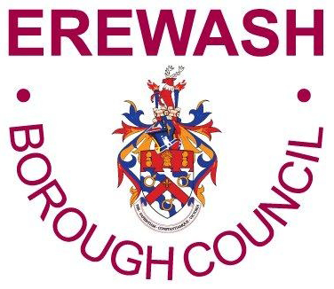
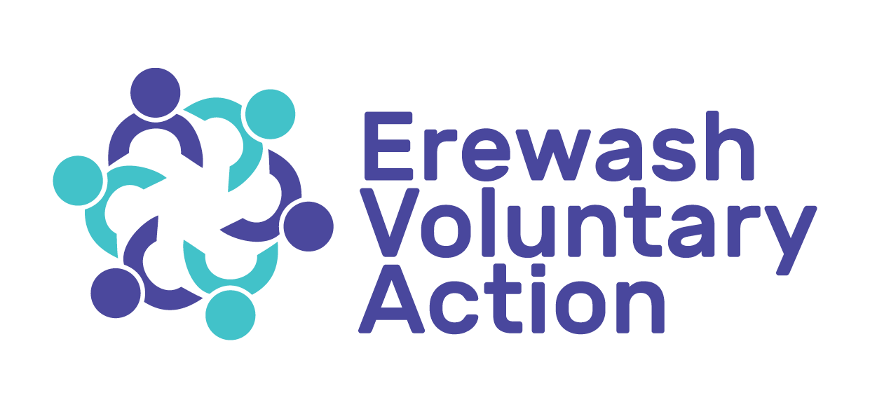

Erewash Voluntary Action – CVS
Erewash Small Grant Scheme – Up to £1,500
Funded by
Derbyshire County Council Public Health
Derbyshire County Council Adult Care Services
Erewash Borough Council

Guidance Notes for Applicants

Before you complete your application form, please take the time to read these guidance notes carefully. They are designed to help you to provide us with the information we need to assess your application. If you need any additional help or advice in completing your application, please contact the Development Worker at Erewash Voluntary Action - CVS on 0115 9466740

General Eligibility

Who can apply?

Applications can be made from any of the following groups:

- Voluntary or community group with a constitution
- Registered charity or CIO
- CIC or other social enterprise
- Other not for profit organisation

Statutory organisations are not eligible to apply to this grant scheme including Parish Councils.

Important Information

It is important that you read and understand this section, as it is a condition of any application that you accept the following:

- All decisions of the Erewash Small Grant Panel are final.
- When an awarded grant expires, there is no commitment to provide any further funding for the project.
- If necessary, we may seek additional information to check your organisation and your application.
- Any attempt to influence the outcome of an application by lobbying an Erewash Small Grant Panel member may result in your application being disqualified.
- We may use the name of your group or organisation and details from your monitoring form as well as your case study in our own publicity or reporting to the grant scheme funders.
- A twelve - month monitoring form will be required to identify how the grant has been spent and the impacts achieved.
- Community Interest Companies are not for profit organisations with the capacity to generate income via selling services/training/resources to become sustainable. Ideally CIC’s do not rely on external funding. To be eligible to apply CIC’s must:

- Be legally set up as a CIC on Companies House. Your CIC 36 Declaration on Formation document must be provided as evidence as well as your Memorandum of Understanding.
- The operation must have a board that incudes at least 3 directors. The directors must not be related or partners living at the same address.

APPLICATION FORM COMPLETION GUIDANCE NOTES

Question 1
We need the name of your group/organisation.

Question 2
The address where your group/organisation usually meets for your activities and meetings. This may be a facility that you own or one that you hire.

Question 3
The name of the person completing the application form.

Question 4
What role the person has who is completing the application form within the group/organisation e.g. chairperson, secretary, treasurer etc.

Question 5,6,7 and 8
Provide the full postal address of the applicant including the post code. Provide an email address, telephone landline and mobile telephone number.

Question 9
If you are affiliated to a national organisation provide the name of the national organisation. If your group or organisation is linked to a larger organisation, such as a national society, you may still go ahead with your application if your group or organisation is fully independent. If your group or organisation is not independent, you will need the written permission and a letter of support for your application from your parent organisation before you can apply.

Question 10
This is the actual name of the project which you are applying for funding. Be clear what the name is so it describes your project.

Question 11
Provide a brief explanation of what your organisation does so it is clear and easy for the grant panel to understand. Include the aims of your organisation where possible.

Question 12
There are three priority themes for the Erewash Small Grant scheme. Your project must contribute to at least one of the priority themes to be eligible to apply. Select at least one theme that you think best fits your application, you may select more that one but rank these in order of priority.

Remember that improvements to quality of life should have a positive health impact and will make a difference for the beneficiaries of your project.

An explanation of each of the themes is described below:

- Health Inequalities including 5 Ways to Wellbeing

Health inequalities are unfair and avoidable differences in the health of groups of people or communities. These differences have a huge impact, because they result in people who are worst off experiencing poorer health and shorter lives. There are many kinds of health inequalities which can involve differences in life expectancy, access to care, health behaviours (such as smoking) and wider issues like poverty, housing and education. Reducing inequalities is important to allow everyone to have the same opportunity to lead a healthy life.

Good mental health is important to help individuals and communities lead a healthier and happier life. 5 Ways to Wellbeing incorporates 5 easy steps that can be taken to improve how people feel each day and include - Connect, Be Active, Take Notice, Keep Learning and Give. Examples of each step are detailed in Appendix A.

Your project would need to contribute to a reduction in health inequalities. It may be a single focus to address an issue e.g. smoking cessation or you may want to link inequalities within a project e.g. a project for young people that includes learning and skill development based in a specific area of deprivation.

Whatever your project is under this priority theme you need to explain how your project will meet the relevant 5 Ways to Wellbeing categories.

- Community Wellness

Wellness is described as a state of complete physical, mental and social well-being and not merely the absence of disease or infirmity. It is a conscious, self-directed and evolving process of achieving full potential.

Community wellness facilitates interventions based on an assessment of community specific health needs.

The most effective community wellness programmes address physical, mental, emotional, environmental, social and spiritual needs.
The aim of Community Wellness is to ensure that people live happy and healthy lives and know where to get help when they need it.
Your project could incorporate any aspect of a community wellness programme focusing on one intervention e.g. mental health or could incorporate more interventions e.g. a physical and mental health project. How you determine this should be based on needs.
There are 7 principles of community wellness these can be found at Appendix B.

- Building Resilience

Building resilience within your group/organisation may include preparing, responding to, and recovering from disruptive challenges. There may be an element of planning and adapting to long term social and environmental changes that are crucial to the future functioning of your group/organisation.

An example of recovery may include adapting to the challenges brought about from Covid 19 and the impact on your group/organisation to respond in whichever way allows your group/organisation to recover and re-start again.

Questions 13 and 14
These questions provide valuable statistical information. Please only tick the boxes that apply to your project – ticking more boxes does not increase your chance of receiving a grant. Remember that your six-month monitoring form will request statistical information as part of the report.

Question 15
This question asks you to provide information as to the beneficiaries of your project so we can understand who the project is aimed at. If there are more than one group of people tick as many that apply. There is space to include groups of people other than those indicated on the application form.

Question 16

If your project involves working with children and young people, we will need to see a copy of your Child Protection Safeguarding policy.
If your project involves working with vulnerable adults, we will need to see a copy of your Safeguarding Adults policy.

Question 17
Tell us about your project and be specific so it is clear what you want to do. Explain how your project will work and how you intend to deliver the project. Describe how it will benefit those that will be taking part in your project.

Explain how it links to the priority theme or themes that you selected in question 12, this is important as it will help inform the panel how your project will contribute and make a difference.

Explain why your group or organisation is best placed to deliver this project.

Do not be tempted to ramble in this section be clear, specific and concise so your project is easily understandable. Use bullet points if this helps.

You must relate how your project meets the priority themes that you have chosen in question 12. Provide clear narrative that demonstrates your understanding of the themes and the impact you expect to achieve within the priority themes applicable to your project.

Question 18
Explain to us how your project will meet a genuine need in the community. How do you know there is a need for the project, have you carried out any needs analysis? Do you have any feedback, evidence of need that will support your application?

It would be useful to have discussed your project with other groups working around this issue.

Question 19
Tell us how people will benefit from taking part in your project, how will their lives improve, what difference it will make and other benefits. What will be the impact on their health and wellbeing?

Link this to your priorities as selected in question 12.

Question 20
Provide an estimate of the number of Erewash residents that will benefit from your project

Question 21
Indicate what area your project will cover.

Question 22
You can apply for up to £1,500 under the Erewash Small Grant Scheme.

Tell us how much your project will cost in total and how much your application is for. Tell us about the costs to participants to take part in your project if relevant.
Provide a detailed breakdown of the funding you require. Do not guess what things cost, obtain quotes or check prices with suppliers before drawing up your budget. Guesswork could lead to you not having enough money to run your project properly.

State clearly the project costs you are seeking e.g. state the number of weeks, be clear on the hours for an activity instructor.

If you are including volunteers as part of your project this has a cash value.

The Erewash Small Grants Scheme does not require groups or organisations to contribute financially towards your project however we do expect that all groups and organisations will contribute to the cost of the project in some way e.g. volunteer time, premises, materials, transport or other contributions in kind.

Ineligible Items include:

- Costs for social outings, trips, celebration meals, transporting members to groups.
- Transport costs unless this is integral to your project.
- Food such as meals out or bought in, other than light refreshments integral to your project.
- Capital maintenance, repair, replacement, new construction or restoration items such as re-surfacing, lighting, re-wiring, new boilers, grass projects or building adaptions

Eligible Items include:
The Erewash Small Grant Scheme is designed to support as many items of expenditure as possible to support applications that are made for funding. There is not an exhaustive list of eligible items, however the following are an indication of the types of eligible items:

- Instructor’s fees for an activity or guest speakers
- Facility costs
- Marketing and promotions
- Equipment – small items
- Training fees
- Running costs such as rent and insurance – this is not usually a cost that would be available to request but will be acceptable within an application under the Building Resilience priority theme due to the impact of Covid 19. Rent costs must not be the total costs for any application.
- Virtual technology e.g. licence for Zoom
- Volunteer expenses

Question 23
If your project costs exceed £1,500 which is the maximum award that can be made, provide details of any other funding you have applied for to support your project. You will need to provide the name of the funding body you have applied to, when you applied, how much you have requested, whether you have been successful and how much has been awarded or if you are pending a decision.

If your project is dependent on match funding and you are awarded an Erewash Small Grant this will only be in principle until your match funding has been approved.

Question 24
Tell us how you will fund the project in the future once the grant money has been spent and how you see that the project will be sustained. e.g. signposting participants, upskilling volunteers, continuation beyond the end of the project, additional funding.

Questions 25 and 26
You must have a Bank or Building Society in the name of your group or organisation to be eligible to apply for a grant.

At least two members of your group must be on the bank mandate.

Question 27
You must agree to complete a twelve-month monitoring form that will request details about how the grant has been spent, the impact, attendance figures, beneficiaries as well impact including a case study.

On receipt and verification of the monitoring report a further £100 will be paid to the group or organisation in recognition of the time required to produce the report.

Signing the Application Form
The application form must be signed and dated by the applicant as detailed in question 3. In addition, it also needs to be signed by a member of your group or organisation committee.

Hand or electronic signatures are required.

Checklist – Documents and Policies to Submit with your application

Before submitting your application go through the checklist on the last page of the application form to ensure that you have all the supporting documents and policies required. Make sure that you have answered all the questions and provided the information requested.

There are no deadlines for applications submit at anytime.

Your application will be assessed by the Erewash Small Grant Panel, and you should hear the decision within a few weeks. If you are unsuccessful the Grant Panel will provide you with reasons for this decision. An unsuccessful application is no bar from reapplying at a later date for a different project.

Groups can apply once every twelve months, but not for the same project. Discuss with the Erewash Voluntary Action – CVS Development Worker.

Guidance on Insurance

What policies have you got? Are the amounts of cover adequate and appropriate for your current activities? What policies should or even must a group have? The cover you need will depend on your group and its activities.

Public Liability.
- This will include legal liability for damages, legal costs and expenses because of injury to the public or damages to their property.
- The minimum indemnity limit must be at least £1 million but many would recommend a minimum amount of £2 million The annual premium for most groups/organisations is likely not to be too frightening, but the peace of mind is worth a lot more. Check that the policy includes costs and expenses in defending proceedings under Health and Safety regulations and acts, as well as damage to hired or rent property and/or equipment, member to member liability and the activities that are included.

- Employers Liability. For any groups or organisations that have paid staff.

- Buildings Insurance. For any group or organisation that own their own premises. If you rent accommodation check the owner’s building policy. What are your responsibilities if you take equipment, particularly electrical, into the building?

Other Considerations

- Equipment or Building Contents Insurance - Check it is a ‘new for old’ policy, are items covered away from normal place of use, or if loaned out, or stored in a private residence.

Insurance does not remove the need to act responsibly.

Further information about available packages and what is suitable for your group can be obtained from Insurance Brokers or Companies.

A list of insurance companies is attached at Appendix C.

Data Protection

All personal information provided will be held and treated in confidence in accordance with the Data Protection Act 2018. It will only be used for the purpose for which it has been given.

Your personal details will be kept securely and for as long as deemed necessary.

You will be asked on the application form to sign your agreement for Erewash Voluntary Action to hold your details as above.

APPENDIX A

5 Ways to Wellbeing

- Connect – Spend time developing and nurturing relationships with friends, family, neighbours and colleagues.
- Be Active – Try to find an activity that you enjoy, and that keeps you active, such as walking, swimming, cycling or playing football.
- Take Notice – Being more aware of the present moment, the world around you and your own feelings and thoughts, can help you to positively change how you are feeling about life.
- Keep Learning – Learning new skills can boost confidence and give you a sense of achievement.
- Give – Helping others, volunteering, saying thank you, or giving someone a smile can help to improve your self-esteem and improve your emotional health.

APPENDIX B

Community Wellness Principles

- Strengthen personal and community assets – physical, emotional, social and financial, grow skills and networks.

- Build community and stakeholder collaboration and partnerships – create and sustain shared vision.

- Have a consistent approach to localities/place – recognise and celebrate local differences and resources.

- Empower people – give people the means to live better lives.

- Have a balanced approach - between universal support available to all and providing additional support for people with greater needs.

- Be holistic – recognise the impact of the wider determinants of health, from the air we breathe to the houses and neighbourhoods we live in.

- Talk to people, communities and workers – co-produce change and connect people.

APPENDIX C

Insurance Companies

1. Access Insurance  www.accessinsurance.co.uk  Tel: 0208 651 7420  Email insure@accessinsurance.co.uk  Selsdon House, 212-220 Addington Road,  South Croydon, Surrey, CR2 8LD | 6. Ladbrook  www.ladbrook.co.uk  Tel: 01909 565858  Email: info@ladbrook.co.uk  5A County House, Waterside Business Park, Rotherham Road, Dinnington, Sheffield,  S25 3QA
2. Ansvar Insurance  www.ansvar.co.uk  ansvar.insurance@ansvar.co.uk  Tel: 01323 737541  Email: ansvar.insurance@ansvar.co.uk  Ansvar House, 31 St. Leonards Road, Eastbourne, East Sussex BN21 3UR | 7. Towergate (Events Insurance)  www.towergateinsurance.co.uk/events-insurance
3. AON  www.insurance.aon.co.uk/business  Tel: 0333 305 4850 | 8. Zurich Municipal  www.zurich.co.uk  Tel: 0800 917 9420
4. Finance ReDirect Limited  www.financeredirect.co.uk  Tel: 01234 358535  Email: office@financeredirect.co.uk  1st Floor, West Wing, Clifton House, Goldington Road, Bedford, MK40 3NF | 9. Ecclesiastical Insurance Group  www.ecclesiastical.com  Email: information@ecclesiastical.com  Tel: 0345 777 3322  Beaufort House, Brunswick Road, Gloucester, GL1 1JZ
5. Keegan & Pennykid  www.keegan-pennykid.com  Tel: 0131 225 6005  Email: enquiries@keegan-pennykid.com  Keegan and Pennykid (Insurance Brokers) Ltd 50 Queen Street, Edinburgh, EH2 3NS | 10. Event Insurance Services (for one off events)  www.events-insurance.co.uk  Tel: 01425 470360  Email: info@events-insurance.co.uk  Event House, 20a Headlands Business Park, Ringwood, Hampshire, BH24 3PB
11. Merkel Direct  www.markeluk.com  Tel: 0333 2425799  Email: customerservice@markeldirct.co.uk  20 Fenchurch Street, London. EC3M 3AZ | 12. BHIB  www.bhibinsurance.co.uk  Tel: 0116 2819100  Email: enquiries@bhibinsurance.co.uk  3 Barton Close, Grove Park, Enderby, Leicester. LE19 1SJ

NB. Presence on this list does not imply recommendation or endorsement.

